**1.0 Introduction**

A team of Virginia Tech Engineers in the Electrical and Computer Engineering Department was brought together with the goal of implementing a project while getting an insight into the professional world of engineering. The team S23-22 is made up of the senior students Fatima Alkaabi, Frank Shay, Jackson Pittman, Greg Brinson and Mariam Singer. The students were assigned the Rear Short Throw Backdrop Project with the Christiansburg Middle School as their client. This Detailed Design Document displays the work that has been done by the team between the months of September and December. This document shows the steps the team has taken as they progressed through the first semester of ECE 4805 and completed the Requirements Analysis, Architecture Design and Detailed Design stages of the two semester course.

The Christiansburg Middle School came to the team with a problem: the School does not have a projector setup that fulfills their needs. The team was tasked with modifying a traditional projector system to support rear-short-throw (RST) projection for a theatrical stage backdrop. The team is aiming to deliver a mounted Rear Short Throw Projector with a Motorized Screen that can be controlled via a remote controller.

**2.0 Design Concept** 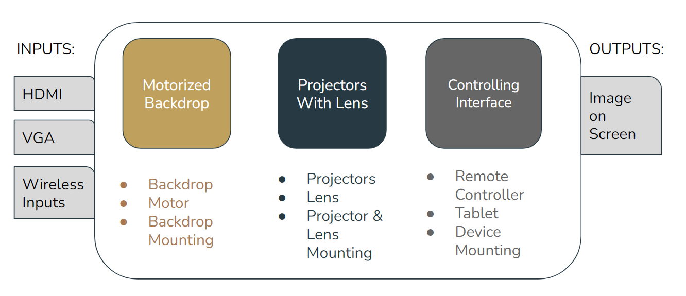

*Figure 1: Image showing the design concept of the project.*

When designing a system, it is important to create a visual, such as the one seen in figure 1, of all the design elements that go into the creation of the system. For this project, the system is made up of three subsystems, a motorized motor, projectors with lens and a controlling interface. These three subsystems are vital to the success of the system and are themselves made of subsystems that are tackled individually as listed later in the document. The goal is to bring together the subsystems and create a fully functional system that takes input of HDMI, VGA and wireless inputs and produces an image on the backdrop.

**3.0 Requirements Specification**

| **Metric** | **Priority** | **Units** | **Marginal**  **Value** | **Ideal or Target Value** |
| --- | --- | --- | --- | --- |
| Throw distance | 5 | Feet | ~12’-13’ | 12.5’ |
| Projection Size | 4 | Centimeters | 800-950 X 300-400 | 915 X 400 |
| Projection Quality | 3 | Pixels | 720p to 4k | 1080p |
| Backdrop Size | 2 | Feet | 30’ by 14’ | 18’ by 14’ |
| Projector lumens | 1 | Lumens | 4000 to 5000 Lumens | 5000 Lumens |

*Table 1: A table listing the team’s specifications with 1 indicating the highest priority*

To set achievable, measurable and realistic goals, the team started the semester by creating a table of requirements specification where each specification is listed based on its priority. The table includes a marginal value that the team has set them an Ideal/Target value that the team has identified that will achieve the customer’s demands. The projector lumens comes first as the goal of the backdrop is to be bright and easily seen from all around the auditorium. The backdrop size comes in second as the customer asked for a specific size that will cover all the space in the back of the stage. The projection quality is third since the team needs to ensure that the image displayed is clear by deciding on the correct projectors and lens. The projector size comes fourth to confirm the projected image fits the backdrop chosen. Finally the throw distance comes in last since throw distance varies depending on where the projector is placed.

**4.0 Architecture Design Concept** 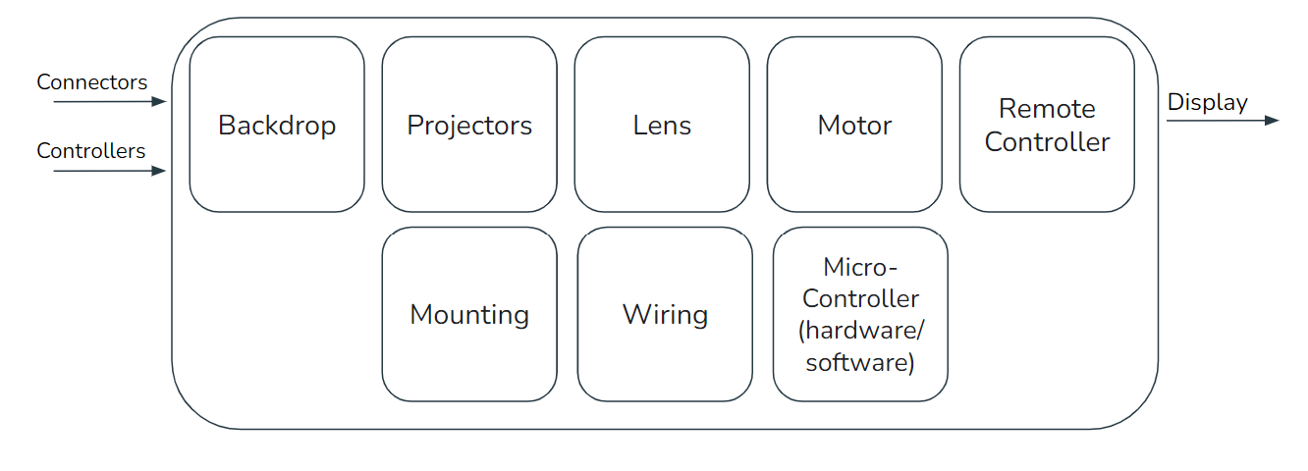

*Figure 2: Image of the project’s architecture design concept.*

Similar to the design concept, the architecture design concept is necessary. The architecture design concept , as seen in figure 2, assesses all the different architectural systems that need to be created to achieve the desired output. For this project, the team needs to work on obtaining the correct backdrop, purchasing the correct projectors and placing them correctly, obtaining and placing the right lens, programming and building the best motorized system , creating the easiest and most functional remote controller, building the best mounting system, considering the best wiring options for a long term project and finally integrating the best microcontrollers to control and program the controllable components of the project.

**5.0 Project Subsystems**

To tackle the design of the project, the system was divided to five subsystem tackled by the five team members:

1. Backdrop: Greg Brinson
2. Lens: Jackson Pittman
3. Motor: Mariam Singer
4. Interface: Fatima Alkaabi
5. Mounting: Frank Shay

The projectors were not included as a subsystem since there isn’t much that needs to be changed or developed for it other than the lens and the mount. In sections 5.2 and 5.5, those subsystems are discussed in detail and will assess the choices taken regarding the projector placements and additional attachments.

**5.1 Backdrop**

One of the most critical parts of this project is the backdrop. It serves as the canvas for the projector to use. It must be the largest size we can manage and fit on the stage as well as fitting the projection size.

***5.1.1 Backdrop Deliverables***

| **Lowest Deliverable:** | Gain 1.0 and Half Angle 30o |
| --- | --- |
| **Desired Deliverable:** | Gain 1.1 to 1.2 Half Angle 30o |
| **Highest Deliverable:** | Gain 1.3 and Above and Half Angle 30o |

*Table 2 : A table showing the lowest, desired and highest deliverables of the Backdrop subsystem.*

This table describes the ranks of screens that we can deliver starting with the cheapest while still adequate option. We anticipate to offer a balance between the highest and desired while still obtaining a manageable cost. Gain any higher leads to other issues, since we do not require that much gain, we can and should pursue options with lower gain.

***5.1.2 Backdrop Specifications and Components***

There are three parts of the backdrop that are of importance to us. Firstly, the size. We need a screen 18’ wide and 14’ tall. 14’ is the height from floor to the shortest curtain and we determined that with our projectors, 18’ wide is the largest image we can project while being visible in a moderately lit room. The second specification is gain. We can manage with a value of just 1.0 but any higher would significantly improve the whole system by making the image brighter. A gain larger than around 1.5 starts to take away from other aspects and limits the half gain angle which would disrupt the viewing experience in the auditorium. It is not worth the tradeoff for our situation. The third and final specification is the half gain angle. The half gain angle is where the projection’s image has half the gain. For instance, a gain of 1.4 would be 0.7 and the image half as bright. These are the things we took into consideration when choosing a backdrop.

***5.1.3 Backdrop Test Plan***

The test is designed to check for proper specifications of the backdrop. The major concern is the proper size. We will measure out the screen horizontally and vertically to ensure proper dimensions. Once our system is set up we can visually check the screen when projected on for adequate brightness throughout the full viewing angle.

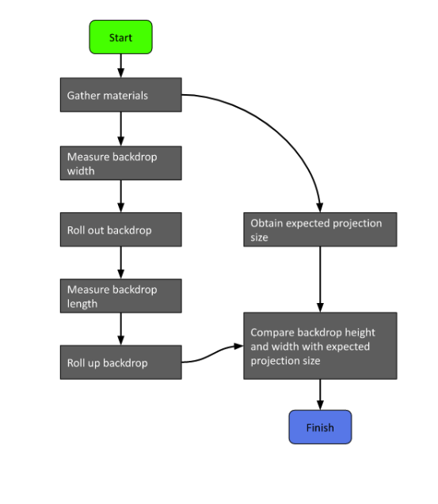

*Figure 3: Flowchart of Backdrop size test.*

***5.1.4 Backdrop Future Steps***

-Acquire screen

-Connect Screen to roller

-Attach motors and drivers

-Place into case

-Mount to ceiling

**5.2 Lens**

The lens assembly is essential to this project for one reason, magnification. The current projection system will not be able to project an image of 18 x 14 ft at the throw distance available. This means the projection system is short throw and additional lenses are needed to accommodate for the shortened throw distance.

***5.2.1 Lens Deliverables***

| **Lowest Deliverable:** | Lenses are fixed focus and in assembly. |
| --- | --- |
| **Desired Deliverable:** | Lenses are mounted custom to projector (non-adjustable) with variable focus lens. |
| **Highest Deliverable:** | Lenses are mounted with a custom and adjustable. The lenses are also variable focus. |

*Table 3 : A table showing the lowest, desired and highest deliverables of the Lens subsystem.*

The above table shows the 3 levels of deliverables our team will be able to achieve. The lowest level is the bare minimum for this project, and is not something our team will deliver. We strive for the highest deliverable possible. This may be either the desired or highest deliverable. Both of these deliverables are excellent solutions to this project and our team is determined to provide a solution that meets the goals of variable focal length and a custom attachment.

***5.2.2 Lens Specifications and Components***

The lens attachment has been chosen by the team to accomplish the short throw aspect of this projection system. With the size of the screen being 18 x 14 feet, the best aspect ratios are 16:9 and 4:3. This gives a screen size of about 18 x 10.125 ft or 18 x 13.5 ft. With these given dimensions and a throw distance of about 151 inches (12.6 ft), the chosen projectors will not have a sufficient throw ratio to project a full size image. With all of this being said, an attachment was needed to make the projection larger and a lens was chosen. Using trigonometry, it was determined that the diagonal field of view of about 84.36 degrees would yield the desired projection size. A number of lenses were considered as solutions to this problem, but the lens that is best suited for our projection system is the Canon EF-S 10-18mm f/4.5-5.6 IS STM lens. This lens offers a variable focal length of 10-18mm which will allow the team to adjust the throw ratio to the perfect size. The full specifications can be found in the table below found on Canon’s website.

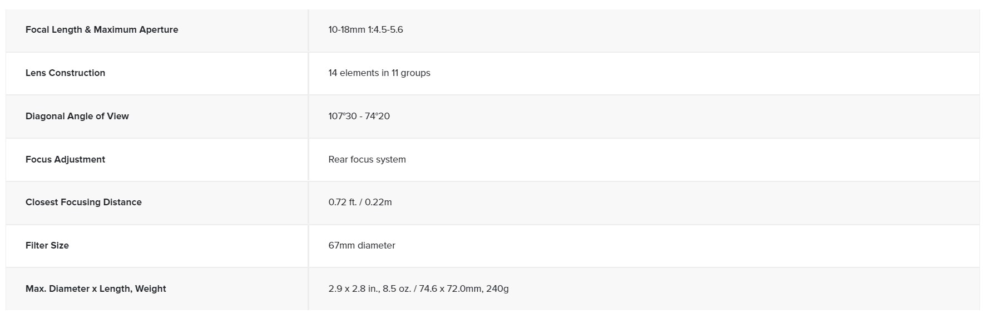

*Table 4: Canon lens specifications*

Our team plans on implementing 2 of these Canon lenses, 1 for each projector. The lenses will be attached to the projectors by a custom designed housing unit. This unit will accommodate for the threading on the projector as well as the lens to ensure a strong and immobile connection between the 2 systems. The projector and lens unit will be able to project a horizontal screen size ranging from 19 ft → 34ft; this is compared to the desired horizontal screen sizes of 20.65 ft (16:9) and 22.5 ft (4:3). This shows mathematically that this lens solution will be more than accommodating for our desired size. In addition, Canon sells these specific lenses refurbished on their website; this makes this solution more affordable and this more desirable. The lenses are sold directly from their website and have a 1-year warranty, purchasing refurbished items is an excellent way to cut prices while still achieving a professional solution.

***5.2.3 Lens Test Plan***

The goal of the lens test plan is to verify the lens projection assembly will project an image at the desired size (~20 ft diagonally) and quality. This will be tested at the fixed throw distance of 151 inches. The below figure goes into detail of the steps that will be taken to testing the lens. Mathematical calculations will be done based on the specifications sheet to determine the image size. Then tests will be performed on campus using the projector to show the image size is as desired. This is the stage when the lenses will be calibrated for our throw distance. The final test is to test the projection in the auditorium and this will be measured using a tape measure.

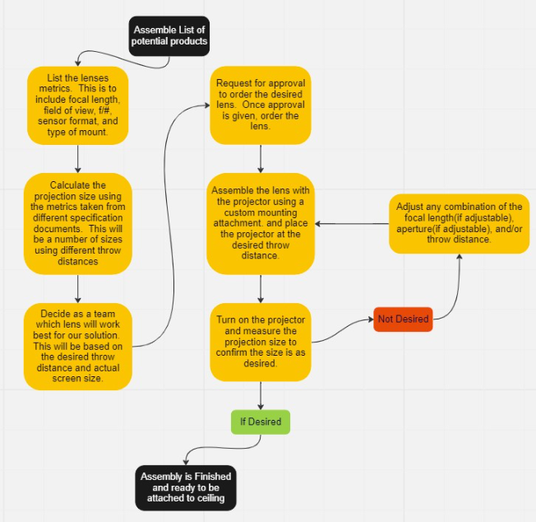

*Figure 4: Flowchart of Lens Test Plan*

***5.2.4 Lens Future Steps***

* Acquire lenses
* Design and model the attachment for projector to lens
* Start to complete test cases
* Take feedback and improve on attachment
* Conduct final tests in the middle school

**5.3 Motor**

An important specification the team will deliver to the customer is for the backdrop to be motorized. Hence, the team is purchasing a motor, driving, controlling, and assembling it with the backdrop screen.

***5.3.1 Motor Deliverables***

| **Lowest Deliverable:** | Motor rolls backdrop screen up and down safely |
| --- | --- |
| **Desired Deliverable:** | Motor rolls backdrop screen up and down safely, consistently, and evenly |
| **Highest Deliverable:** | *Motor rolls backdrop screen up and down safely, consistently, evenly, and with a user controlled speed* |

*Table 5 : A table showing the lowest, desired and highest deliverables of the Motor subsystem.*

As shown in the table above, the team has listed 3 levels of deliverables. For the lowest deliverable the team would have the motor to roll up and down the screen safely. For the desired deliverable, the team would have the motor roll up and down the screen safely, consistently, and evenly. Lastly, for the highest deliverable the team would add more user control such as adjustable speed of rolling the screen and screen’s position in height.

***5.3.2 Motor Specifications and Components***

Research was conducted on the different types of motors including brushed DC, brushless, servo, and stepper motor. By utilizing the cost, torque, and functionality and comparing the different motors, stepper motors were found to be the best option to motorize the backdrop screen. A stepper motor is a type of brushless DC motor that divides full rotation into a number of equal steps. It has precise positional control and tracking, hence it will work well for the purpose of rolling up and down the backdrop screen. A brushed DC motor is usually on the cheaper side, however it is targeted towards functionalities that are less reliant on power-to-weight ratio and its positional accuracy is not ideal. Brushless motors have greater reliability, faster maximum speeds, and better efficiency, however its positional accuracy is not ideal as well as it is one of the more expensive motors. As for Servo motors, they have great positional accuracy and high torque but they are even pricier than the brushless motors. Finally, stepper motors have precise positional control and tracking, use relative positioning, and have a high torque. Stepper motors do not have the best maximum speed, but for the purpose of rolling the screen, this will not be an issue. Compared to brushless and servo motors, stepper motors are less pricey, have a higher torque and pole count. Hence, the team decided to work with a stepper motor.

Once the team decides on the stepper motor, the next step is to pick the model and the specifications. Based on the screen’s size, 18 x 14 feet, and weight, 47 pounds, the best model to tackle motorizing the backdrop screen would be the NEMA 34 stepper motor. The NEMA 34 is one of the bigger stepper motor models which can move a lot of weight at 1200 ounces/inches. The NEMA 34 can theoretically lift 750 pounds which will ensure no conflicts with the motor holding the screen’s weight along with its weighted bar. The NEMA 34 have torques that range at 6NM-15NM and currents that range at 2A-10A. For motorizing the screen, the team will be using a NEMA 34 with a holding torque of 12 NM and current of 6.0 A which can be found on eBay for $57.0, model diagram and specifications can be seen in the figure below. The motor will need a driver for power supply; the driver for the NEMA 34 stepper motor can be found on eBay for $41.0. Two NEMA 34 motors were placed for order as having two on each end of the projector screen always for stable and wrinkle-free rolling.

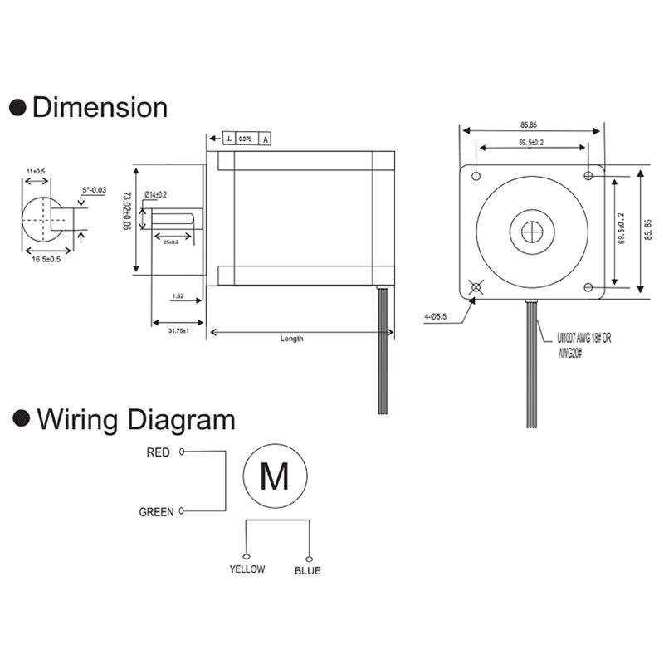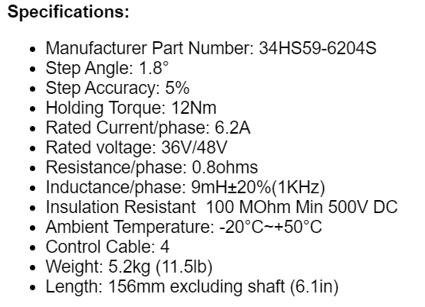

*Figure 5: NEMA 34 dimensions and specification*

Additional components that the team will need are two stepper motor drivers and two power supplies. The driver chosen for the motors is the STEPPERONLINE DM860I which is a driver suitable for NEMA 24 to 34. The drivers are supplied with 60 VDC through the power supplies. The power suppliers chosen are the STEPPERONLINE Switching Power Supply Stepper Motor which will be supplied 230 VAC. The power needed for the motors to roll the screen down in 30 seconds would be 75.4 W which is easily provided by the power supply. The motor will be controlled through the Raspberry Pi 3 Model B+ and Python code. The synchronization of the motors will also be assured through the code. Another way to allow for motor synchronization is using the same driver for both motors if the first method is unsuccessful.

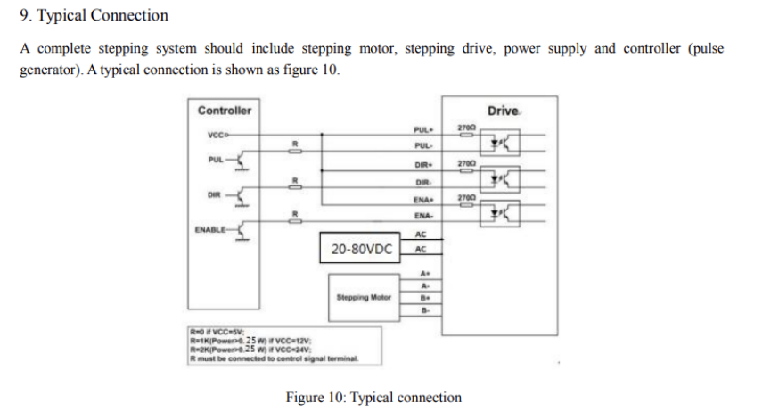

*Figure 6: STEPPERONLINE DM860I Nema 34 Digital Stepper Motor Drive*

Calculations were done to ensure that the motor has enough torque depending on the pipe the screen fabric will be rolled on. The maximum diameter of a pipe that should be purchased is a 2 inch diameter pipe which will require a maximum torque of 10.45 NM. As for preventing deflection, a 2 inch diameter 21 feet long steel pipe would be the right choice. However, due to a steel pipe being extremely heavy, deflection will be prevented through the backdrop screen case design.

The wiring diagram of all the components is shown in figure 7 and the progress of wiring is shown in figure 8. The components arrived but the only thing the team is awaiting is the power supplies.

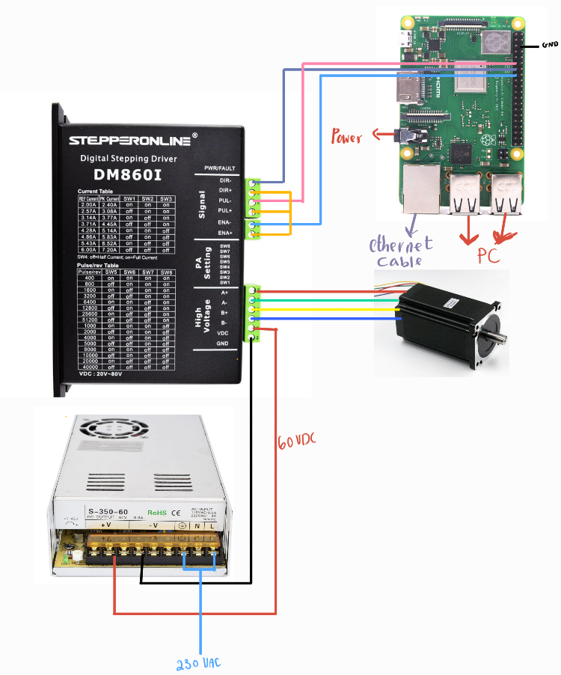

*Figure 7: Motor, Driver, Power Supply, and Raspberry Pi Controller wiring diagram*

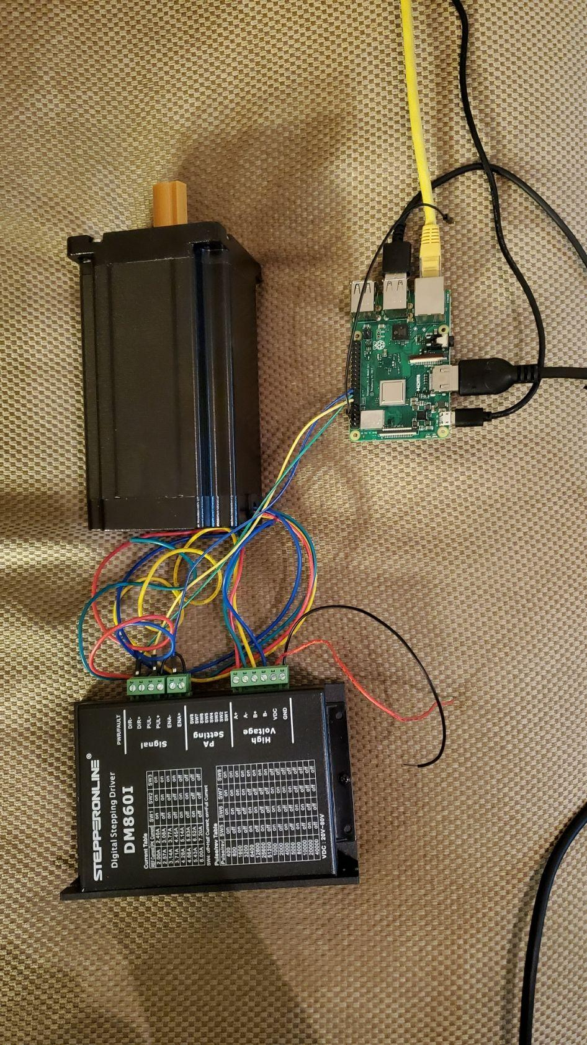

*Figure 8: Motor wiring (awaiting the power supply to arrive)*

***5.3.3 Motor Test Plan***

* Upon the motor delivery, testing will be conducted with the driver and Raspberry Pi microcontroller to ensure that it is rotating at desired speed. YouTube videos of stepper motor testing are widely available and will be used as guidance.
* Once the motor is working as desired, testing will be conducted with a smaller component such as a roll up screen or shade. The motor should be able to roll up and down the smaller screen or shade before moving on to test it with the backdrop screen.
* Finally the team will test the subsystem with the backdrop screen, keeping track of efficiency and speed of rolling.

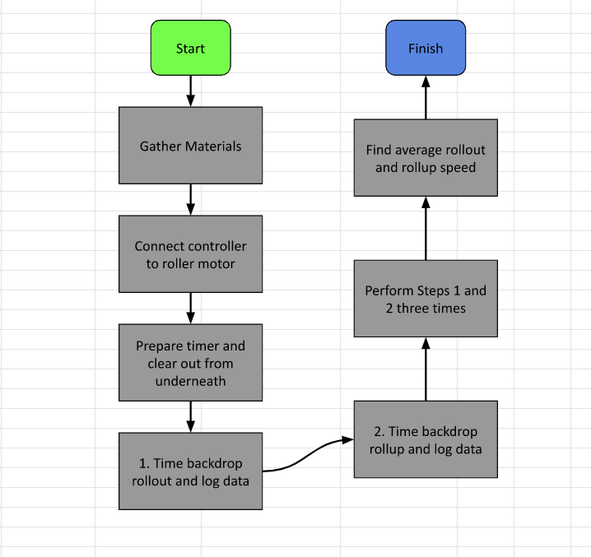

*Figure 9: Motor test plan*

***5.3.4 Motor Future Steps***

* The team will purchase the stepper motor, the stepper motor driver, and the power supplies.
* The stepper motor will be wired with the components and set up with its driver and Raspberry Pi microcontroller.
* Team will find suppliers to fabricate the backdrop case which will provide support and balance for the backdrop
* Finally, the team will conduct final tests before mounting the motorized screen in the middle school auditorium.

**5.4 Interface**

No project is complete without ensuring that the best User-Experience is offered to the customer. After conversations with the customer and brainstorming ideas to add innovation to the project, the team has decided to improve the controlling capabilities of the system by introducing an innovative controlling interface. The interface handles controlling the motorized screen and the outputs on the projector.

***5.4.1 Interface Deliverables***

| **Lowest Deliverable:** | Remote Controller for Projector & Backdrop Motor. |
| --- | --- |
| **Desired Deliverable:** | Remote Controller and *Tablet* to control Projector & Backdrop Motor (Stationary). |
| **Highest Deliverable:** | Remote Controller and Tablet to control Projector and Backdrop Motor with *additional creative features including backdrop animation (mobile) .* |

*Table 6: A table showing the lowest, desired and highest deliverables of the interface subsystem.*

As seen in table 6, the team has set three deliverable levels. For the interface, the team has chosen the Remote Controller for the projector and backdrop motor as the lowest deliverable. The reason it was chosen as the lowest one is because that option is easily achievable and provides no innovation. The desired deliverable is a Remote Controller and Tablet to control Projector & Backdrop Motor (Stationary). This approach is the desired deliverable since it has innovation with the addition of a tablet being used as a control station. The fact that this option is stationary makes the plan to implement it more realistic and feasible to the team. The highest deliverable is the same as the desired deliverable with additional creative features such as the ability to animate your own backdrop and the ability to carry the tablet around instead of it being stationary. The highest deliverable is not impossible to achieve but with the team;s limited time and funds, we will only be considering the addition of these features if there is space to implement them before the product needs to be delivered to the customer.

***5.4.2 Interface Specifications and Components***

The goal of the interface is to bring together all the controllable subsystems of the project in an easy to use interface. The main two functions of the interface is to control the motorized backdrop and to control the inputs of the projector. The first function of rolling the backdrop up and down will be controlled fully allowing the user to control how high or how low they want to roll the backdrop. This function was added to avoid injuries since the option of automating the rolling of the backdrop could cause accidents. The team has resorted to the option of giving the customer full control of rolling the backdrop since adding sensors to detect any moving objects under the screen will be an additional subsystem that the team cannot include with the given time and budget. The second function is to control the inputs of the projector. Through the controlling interface, the team aims to allow the customer the ability to control which inputs are being displayed on the backdrop.

The team plans to achieve those specifications by offering the customer two things: a remote controller and a tablet. The remote controller is just a basic controller with buttons that will allow the user to control the rolling of the screen and the projector settings from anywhere. The tablet is an innovative addition to the project that will be acting as a stationary control panel performing the two functions mentioned earlier. For the inputs of the device, the team plans to give the customer the option to connect wired inputs including HDMI and VGA since they are the two most commonly used cables when it comes to projectors. The team is also giving the customer the ability to connect devices wirelessly using a Wireless HDMI Receiver. The team aims to create a safe network that the customer can only access to minimize any external interference with the wireless receiver. That can be achieved using a password or a physical transmitter that the team will look into once the choice of the Wireless HDMI Receiver is made.

Additional creative features can be added to the interface that the team aims to include if the time allows. The creative features include using the tablet as the main input to the system. The screen can also display the most commonly used applications by the customer such as google drive and youtube. The main creative feature the team hopes to include is the ability for the students to animate their own backdrops directly from the tablet. All of these additional features will add so much to the User Experience and the team hopes to be able to include those features if the time permits. Below is the physical components of the project to achieve the team’s vision:

| ***Image of Component:*** | ***Description of Component:*** |
| --- | --- |
|  | ***Raspberry Pi Official 10.1 Inch Touch Screen for Raspberry Pi 4 / pi 3/pi 2 Model B***   * The Raspberry Pi screen was chosen to allow freedom of programmability of the GUI. The screen easily connects to the raspberry pi. * Status of Components: Ordered (Est. Arrival Dec 7th, 2022) * Price: $60 |
|  | ***Raspberry Pi 3 Model B x 2***   * The Raspberry Pi 3 Model B was chosen as the microcontroller of the system for its ease of use and numerous functionalities. * Status of Component: Received and were provided by the ECE department. * Price: Free |
|  | ***NEMA 34 Stepper Motor and Driver***   * The stepper motor information is mentioned in the motor section 5.3. The motor will be controlled by one of the raspberry pi boards. * Status of Component: Not Ordered Yet. * Price: $98 |
|  | ***3D Printed Mount/Stand for Charging Station***   * To hold the tablet, a 3D printed mount/ stand needs to be designed and printed. The choice of stand or mount can vary depending on the customer’s preference. * Status of Component: Not Designed/Printed Yet. * Price: Free |
|  | ***Wireless HDMI Receiver***   * To allow wireless inputs to be projected, a wireless HDMI receiver can be used. The HDMI receiver will be connected to the back of the projectors. There are many variations of this product and the team will be purchasing the suitable one depending on the tablet design. * Status of Component: Not Ordered Yet. * Price : $22-$125 |
|  | ***Additional Cables: HDMI, VGA***   * Additional cables will be needed to allow wired inputs to be projected. The team is looking into 30 ft cables. * Status of Component: Not Ordered Yet. * Price: ~$20 each |

For the software aspect of the interface, the team will be using the Raspberry Pi to code the GUIs and functionalities of the project. The team will be placing one raspberry pi by the motor and the other one will be connected to the raspberry pi screen allowing communication between both. Another raspberry pi might be needed to be paired with the projector to allow the control of the inputs of the projector. To program the tablet, the team will be using pre existing libraries that handle GUIs such as PySimpleGui , Tkinter or Qt. There is so much flexibility when it comes to the GUI design so things might vary and change compared to the figure below. Figure 10 shows an overall sketch of the system and how it will look.

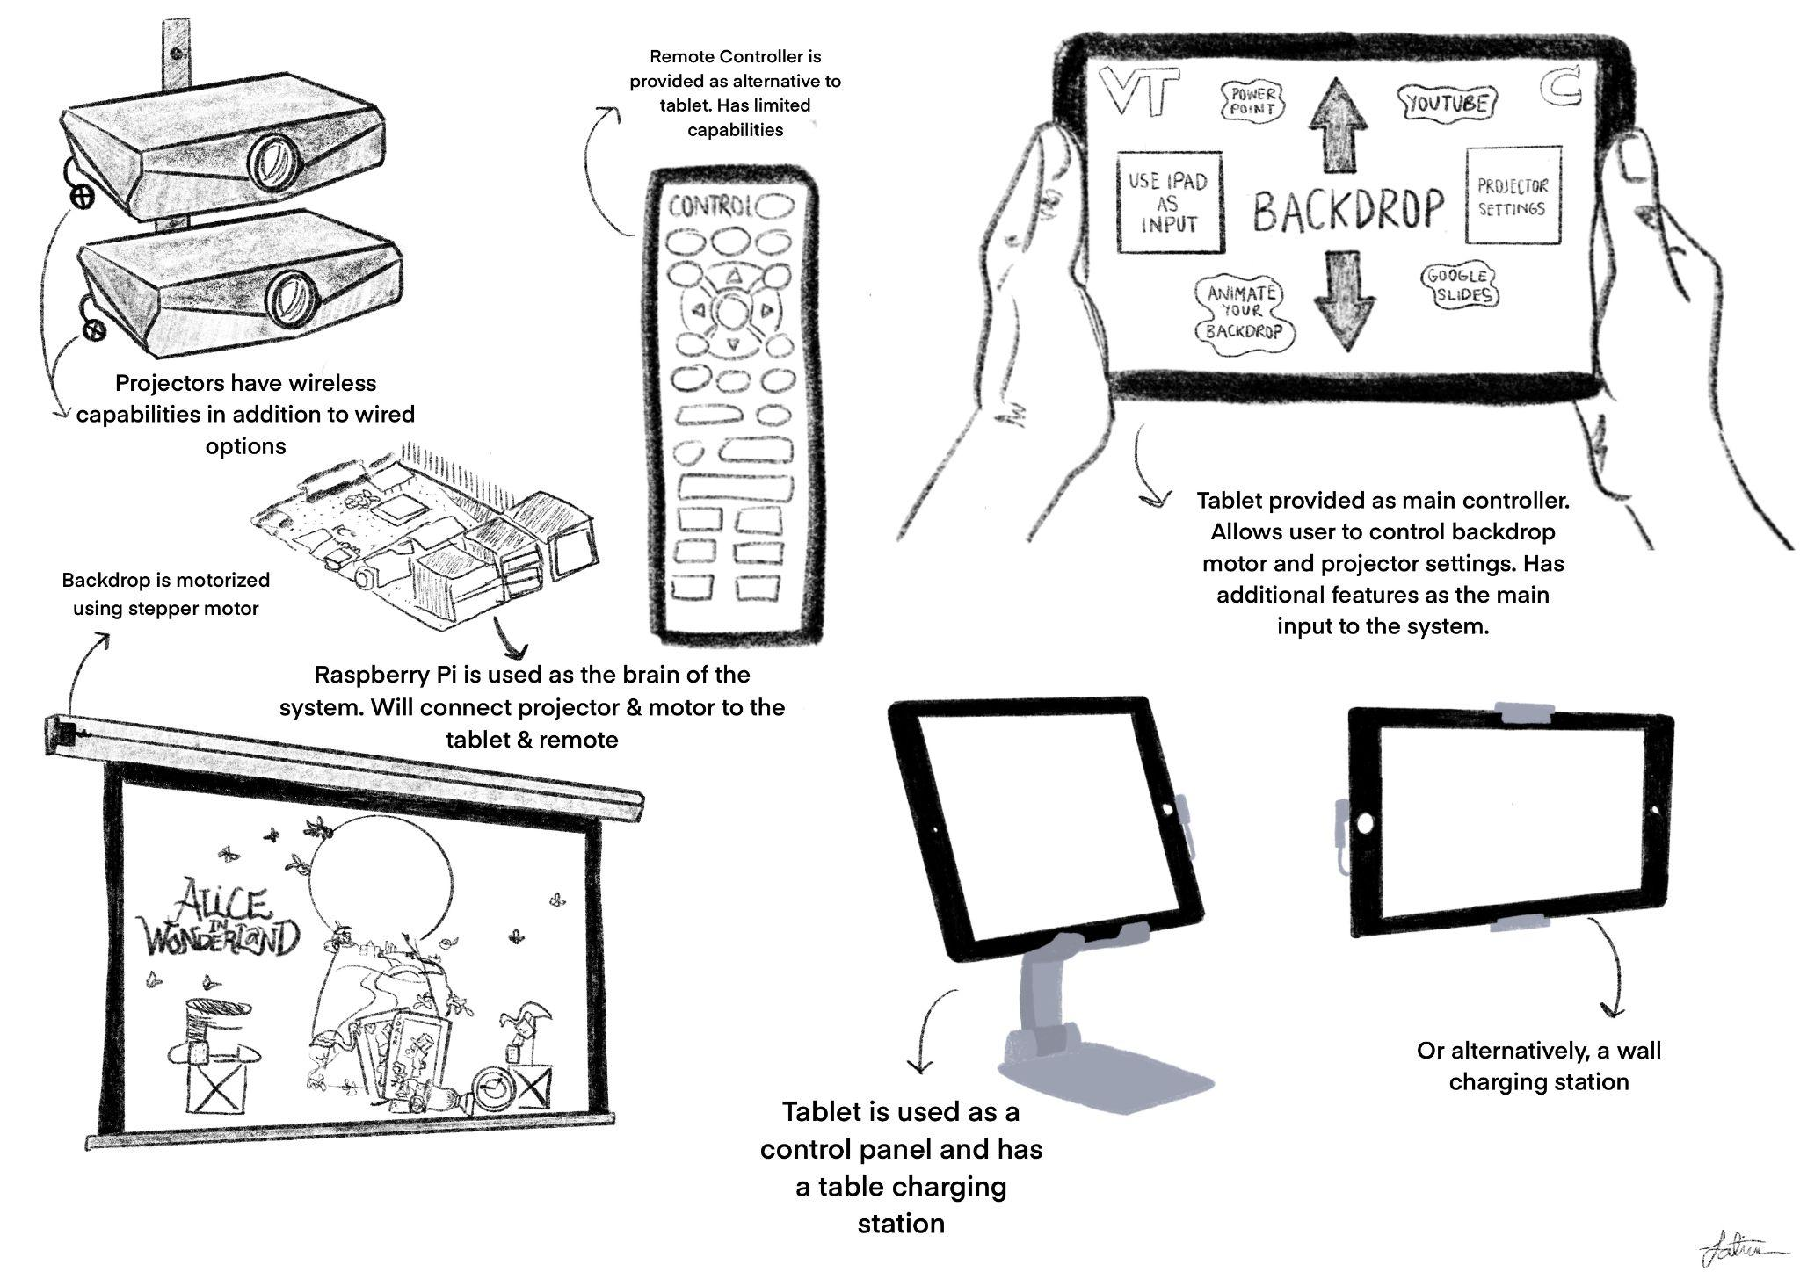

*Figure 10: Sketch of the overall interface system showing all the subcomponents including the wireless connection, the mount/stand for the tablet and the remote controller.*

***5.4.3 Interface Test Plan***

To test the interface, the team needs to implement the following steps:

* Ensure all components of the remote controller are connected and work as intended such as rolling the backdrop up and down and turning on the projector.
* Ensure tablet controlling capabilities work and the tablet fits in the charging station/stand as intended.
* Ensure that the Customer is satisfied with the User experience of the application created.
* Ensure that the Customer can connect all kinds of inputs, both wired and wireless.
* Conduct these tests multiple times including a final test on site.

***5.4.4 Interface Future Steps***

As the team approaches the end of the semester, future plans for the interface were made as seen below:

* Receive order of the tablet and cables made in the last week of November.
* Order additional items such as programmable remote and wireless receiver.
* Start design and development of tablet applications.
* Test tablet Capabilities through User-Experience Focused testing.
* Conduct additional tests in Middle school when all components are installed.
* Use remaining time to improve the capabilities of the tablet.

**5.5 Mounting**

As well as the project is designed, if the mourning of the project is not well designed and followed then the project will never be able to effectively come together. Even if all individual aspects are designed perfectly, if the project is put together wrong then the system will be a failure. The Mounting of the project can make the difference between everything working together perfectly or

***5.5.1 Mounting Deliverables***

| **Lowest Deliverable:** | The Projectors are mounted and powered |
| --- | --- |
| **Desired Deliverable:** | The Projectors are neatly mounted and powered with good cable management |
| **Highest Deliverable:** | The Projectors are neatly mounted and powered with good cable management and it fit the color scheme of the auditorium |

*Table 7 : A table showing the lowest, desired and highest deliverables of the mounting subsystem.*

The table above shows us the three deliverable levels that our team has. The bare minimum of our project is that the projectors need to be mounted and powered for us to make projections occur. This is the bare minimum because we cannot allow delivering anything less than a fully working product to our customer or the project would have been an extreme waste of time and money. The second level we look at is neatly mounted projectors that have good cable management to allow for the ease of use of the projects and safety. The cables can be safety problems as we will have a lot of middle schoolers running around in the back of the auditorium and the students might trip on the cables and hurt themselves or even tear the mount out of the wall. The highest deliverable options occur when we allow the mount to not be an eye sore to the auditorium and get it to fit in the color scheme of the auditorium. This would be ideal as there is already an ecosystem set up in there and we don't want to come in and destroy part of the aesthetics of the building.

***5.5.2 Mounting Specifications and Components***

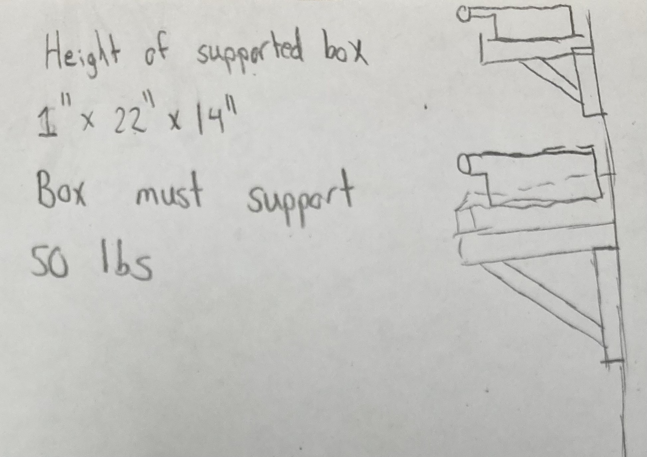

*Figure 11: Sketch of projector mount.*

Our mount has to be designed so that the Christiansburg Middle School can easily help us in the production of putting up the mount. We have to use a combination of the Virginia Tech lab to build the mount and we will need the Middle School staff as we have to drill precise points into a concrete wall to make sure that it is stable.

The basic design specifications that we have to follow are the shelves have to be able to hold the projectors, must be 15 feet off the ground, hold 75 lbs of weight, hold a shelf with a width of 14 inches and support a section for the cables so that they are not hanging in the way. Before we accomplish the hanging of the mount we are going to need to spray paint all of the pressure-treated wood black to stop the overall build of the project from sticking out like the rest of the auditorium. This is going to be accomplished by using two L brackets to hold up a rectangular piece of wood that will support the projector. A rectangle wooden shelf will then have walls attached to it on each side to be able to hold the projector stable. A hole will be cut out of the front side for the projector to shine through. There will also be holes cut out off the back so the VGA and HDMI cables can be neatly threaded through and plugged into the projectors. The cables will then be neatly mounted on to the walls for the cables to not to be tripping hazards for those using the projector and in order for the support system to not be yanked out of the wall by any chance. The cable will also be wrapped in a protective cable casing for the installation to be more permanent. This way it is protected from any west and tear that the cables may get over the years and cause it not to break down. This is extremely important because as the designers of the project are leaving we want to make sure we leave the customer with a long-lasting project that they won’t need any expertise fixing. The cables are long enough and will lead to a place where they can easily be plugged into and used without being in the way of whatever they may be presenting.

The overall plan of the project is to leave a long-standing, efficient, and well-looking mount for our projectors. This will make sure all of the pieces of our project come together nicely and that none of the work or money goes to waste.

***5.5.3 Mounting Test Plan***

* We need to make sure the power outlet is working properly
* The stiffness of the L bracket needs to be tested and proper installation techniques need to be followed
* With all splitter cables and large power sources, we need to make sure the wall outlet can handle all power being used

***5.5.4 Mounting Future Steps***

* We need to secure the power cables and VGA cables long enough to reach the mounted projectors
* We need need to secure splitter cables so that we can setup both projectors
* The L bracket that can secure the weight needs to be purchased and it also has to be tall enough to hold both projectors
* Proper installation techniques need to be written so that safe installation can occur

**6.0 Schedule**

For the upcoming semester, the team has created a schedule to achieve the goal of delivering the product to the customer by March:

* **January:** 
  + Place orders early January for any missing Components.
  + Start software design for tablet and any 3D-Printed Components.
* **February:** 
  + Have all 3D-printed components printed.
  + Have all ordered components ready for installation.
  + All subsystems should be 75%-80% function by late February.
  + Conduct on campus tests on the subsystem of the project individually and then conduct group tests with all components.
* **March:** 
  + Mount system components in Middle School.
  + Conduct tests in Middle School.
  + Take final feedback from customers.
  + Use remaining time to introduce more innovation to the project.
  + Prepare for showcase at MDE.

**7.0 Budget:**

***7.1 Backdrop Budget***

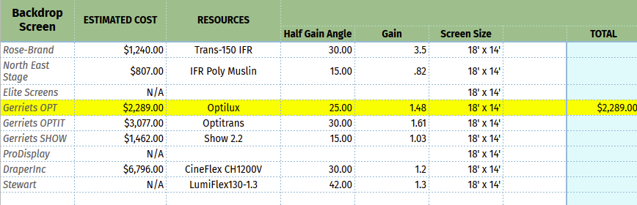

*Figure 12 : Image of Backdrop of Budget Plan*

This table shows all the options considered when purchasing the backdrop. The highlighted option is the one we are pursuing. It had a moderate price with average half angle and exceptional gain.

***7.2 Lens Budget***

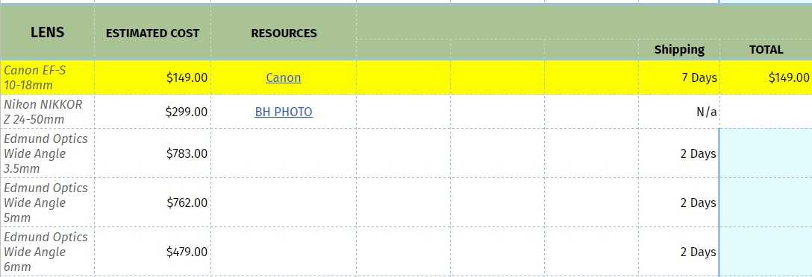

*Figure 13 : Image of Backdrop of Budget Plan*

The above table shows the potential lenses for our project with the lens highlighted in yellow being the best solution for this project.

***7.3 Motor Budget***

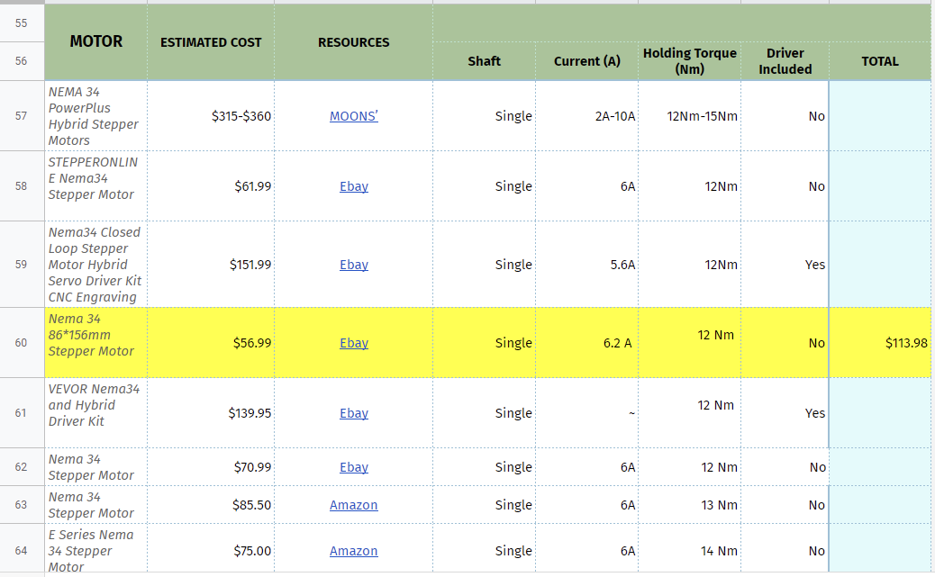

*Figure 14 : Image of Motor Budget Plan*

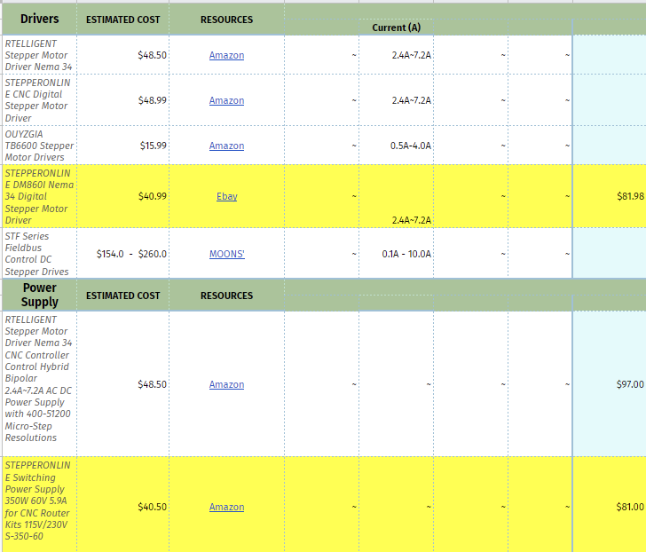

The figure above shows the budget of the motor and its driver. All the options considered were listed above and the highlighted motor and driver signify the best options to purchase. The motor with desired specifications was found in a new condition on eBay for $56.99. The driver for this specific motor was also found on eBay in a new condition for $40.99. The team does not have to worry about shipping as it takes 2-4 days to ship these items. The total cost of the 2 components would add up to be $98.00.

***7.4 Interface Budget***

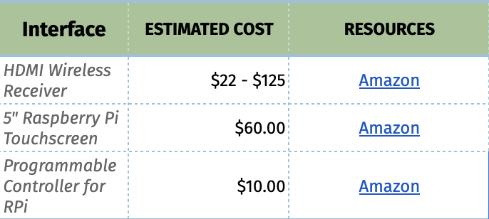

*Figure 15: Image of Interface Budget Plan*

As seen in the image above, the interface budget, including the components that are exclusive to the interface rounds to about $185. The price of the wireless receiver will vary depending on what choice is taken by the team. The Raspberry Pi Touchscreen is about $60 but the member of the team responsible for the interface, Fatima, has already ordered one for tests and will probably be donated to the project changing the screen price to $0. Also depending on the programmable controller chosen by the team, the price might increase. Most options are around $10-15.

***7.5 Mounting Budget*** 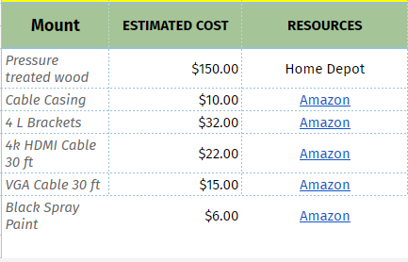

*Figure 16 : Image of Backdrop action of Budget Plan*

The above shows the information for the Mounting part of our budget. To make the mount that the middle school will be putting up we will need all of the materials. The materials all have less than a week shipping times and therefore should not be a problem. All of the materials will be new and therefore should come together nicely. I will be asking Home Depot if they could give a discount on the wood because it is going to be a Middle school project and hopefully that can save us some money as well.

***7.6 Additional Components Budget***

Since we are working for the Chstiansburg middle school we will be able to get some parts cheaper than retail. The projectors we have bought were very generously donated to be used as part of our project. Also we will be in contact with companies in order to ask for a donation or reduction in price in order to get cheaper parts. Our budget seems to be within the funding that we have for the project and very reasonable for a project of this scale.

**8.0 End Product**

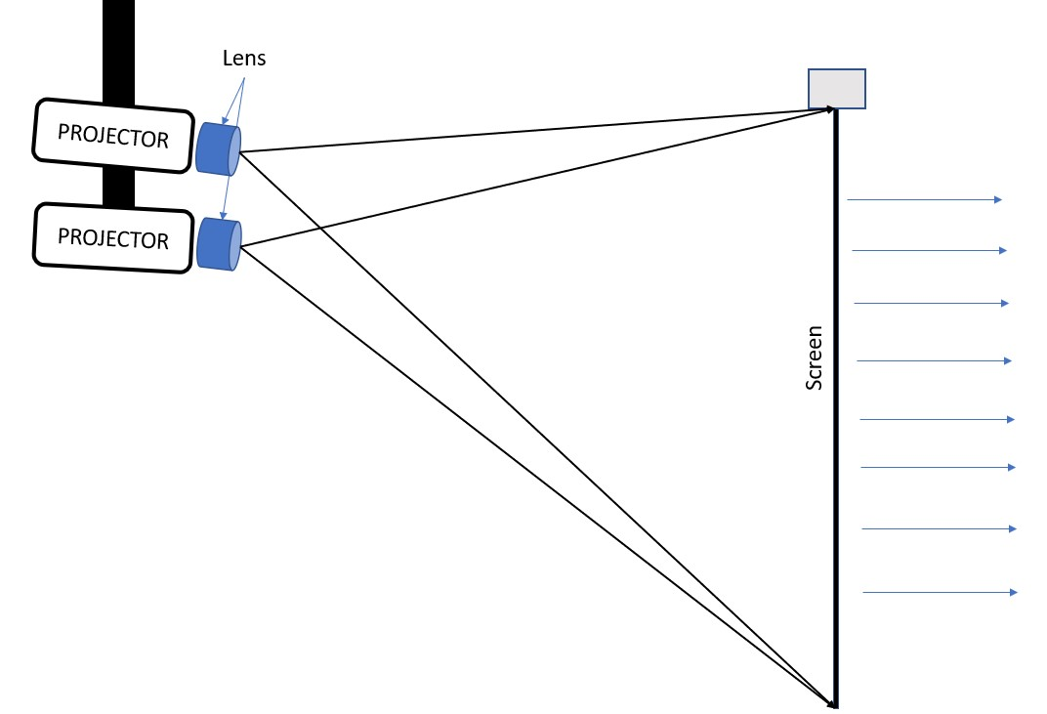

*Figure 17: End product*

The team will provide a completed and fully tested end product to the customer. The team will deliver a double projector system mounted to the back wall of the Christiansburg Middle School’s auditorium stage. The team will provide a rear short throw projection system, hence the projectors mounted behind the backdrop screen and there will be no risks of casting shadows onto the backdrop. The backdrop will be automated using the stepper motor and system interface as explained more in detail above. The system will provide all the port/ power connections needed for the system to work as desired. The backdrop will be mounted in the Christiansburg Middle School’s auditorium, have a size of 18 x 14 feet, and a projection size will be 915 x 400 as specified by the customer. The end product will be tested and delivered to the customer by the end of March 2023.